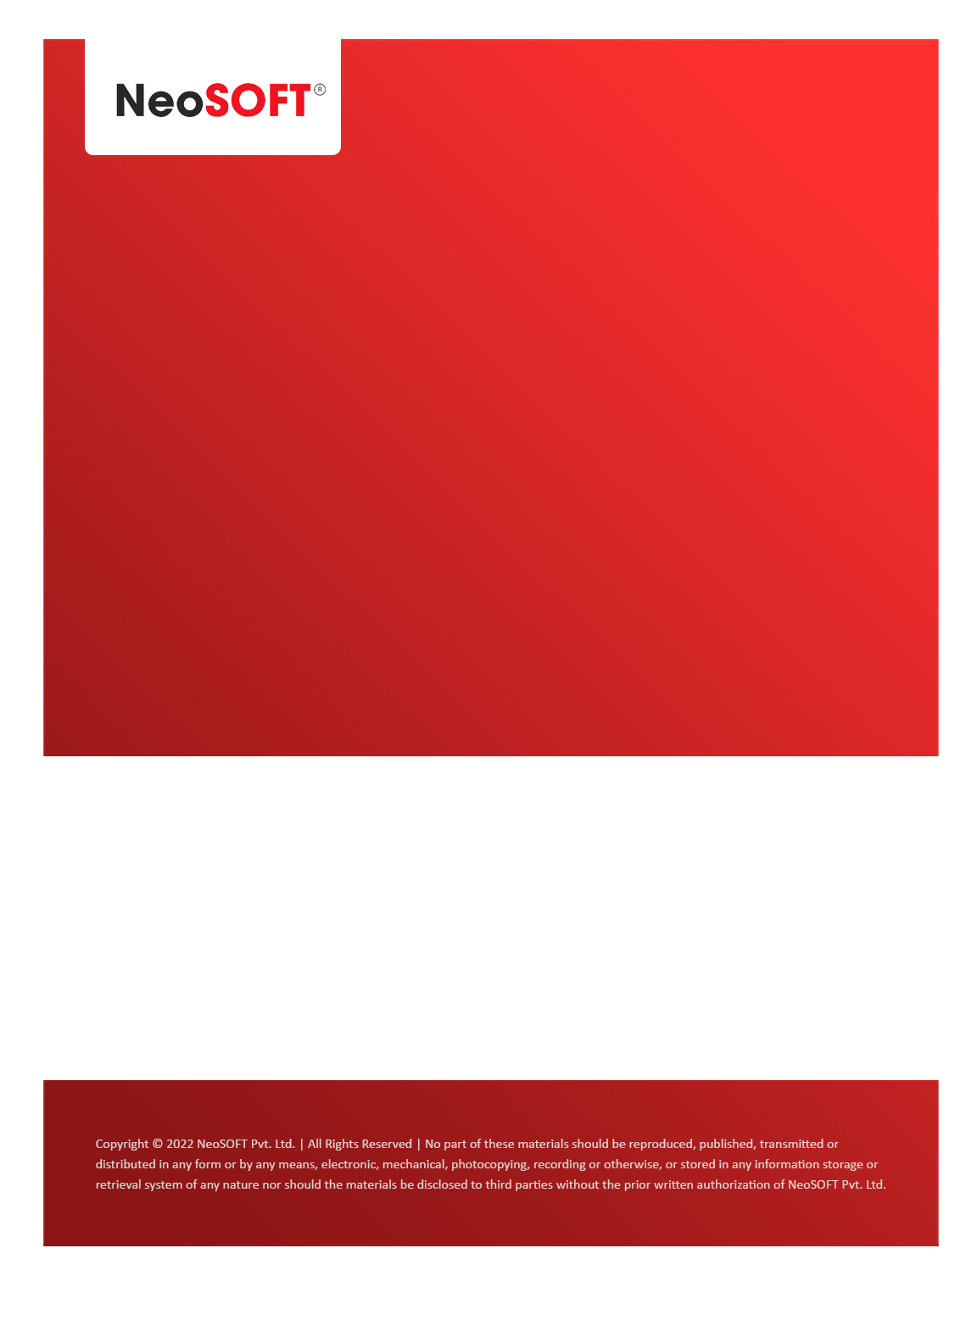`

**Eltizam**

**MOM – Manager’s meet**

Eltizam

Client Name

NeoSOFT is a SEI-CMMI Level-5 Global IT Consulting & Software Solutions Provider

**April 06**, 2023

|  |  |
| --- | --- |
| **Meeting Date, Time, and Attendee Details** | |
| **Date** | 6th April 2023 |
| **Venue** | MS Teams |
| **Time** | 06.30 PM – 07.00 PM IST |
| **Meeting Type** | Angular Front End CR, Payments discussions |
| **Internal Attendees** | * YallaReddy * Karthik Natarajan |
| **Client Attendees** | * Vinod Kumar |
| **MOM Prepared By** | * YallaReddy |

|  |  |
| --- | --- |
| **Details of Meeting** | |
| **Sr. No.** | **Description** |
| 1 | In today’s call, We requested Vinod to make wireframe review on time with stake holders to void rework. |
| 2 | Discussed adoption of Angular as front end & informed that additional efforts are needed can be treats new Change Request (CR). |
| 3 | Vinod is confirmed that, payment will be settle to NeoSOFT by Tuesday i.e., 11th April 2023. |
| 4 | NeoSOFT team will submit Angular UI Change Request (CR) with all details to Eltizam by next week. |
| 5 | Presented wireframes to Vinod on top level. Tomorrow, we have meeting to discuss wireframes, SRS documents. |

|  |  |  |  |  |  |
| --- | --- | --- | --- | --- | --- |
| **Actionable** | | | | | |
| **Sr. No.** | **Action Item** | **Assigned to** | **Assigned Date** | **Expected Completion Date** | **Status** |
|  |  |  |  |  |  |
|  |  |  |  |  |  |
|  |  |  |  |  |  |